**Oracle APEX Workflow**

**Create the App**

1. Navigate to **App Builder**
2. Click **Create**
3. Click **New Application**, for Name - enter Expense Reimbursement.

## Sample Table and Sample Data

1. Navigate to **SQL Workshop** and click **SQL Scripts**
2. Click **Create**
3. Copy and Paste the commands given below into the Script Editor to create a new Table APPROVAL_LEVELS and insert the manager records into it.
4. Click **Run**
5. Click **Run Now**.

**CREATE TABLE "APPROVAL_LEVELS"**

**("LEVEL_ID" NUMBER GENERATED BY DEFAULT ON NULL AS IDENTITY MINVALUE 1 MAXVALUE 9999999999999999999999999999 INCREMENT BY 1 START WITH 1 CACHE 20 NOORDER NOCYCLE NOKEEP NOSCALE NOT NULL ENABLE,**

**"MGR_NAME" VARCHAR2(255),**

**"MGR_EMAIL" VARCHAR2(400),**

**"LEVEL_CODE" NUMBER DEFAULT 1 NOT NULL ENABLE,**

**CONSTRAINT "APPROVAL_LEVELS_PK" PRIMARY KEY ("LEVEL_ID")**

**USING INDEX ENABLE**

**) ;**

**insert into APPROVAL_LEVELS**

**values (10, 'JANE','jane@expenseteam.com', 1);**

**insert into APPROVAL_LEVELS**

**values (20, 'MATT', 'martin@expenseteam.com', 1);**

**insert into APPROVAL_LEVELS**

**values (30, 'BO', 'bo@expenseteam.com', 2);**

**insert into APPROVAL_LEVELS**

**values (40, 'CLARA', 'clara@expenseteam.com', 2);**

**insert into APPROVAL_LEVELS**

**values (50, 'SUSIE', 'susie@expenseteam.com', 3);**

## Creating the Task Definition

In the empty Application, we go to the Shared Components→ Workflows and Automations→ Task Definitions and hit **Create.**Fill in the Create Task Definition Wizard fields as shown below, and hit **Create**.

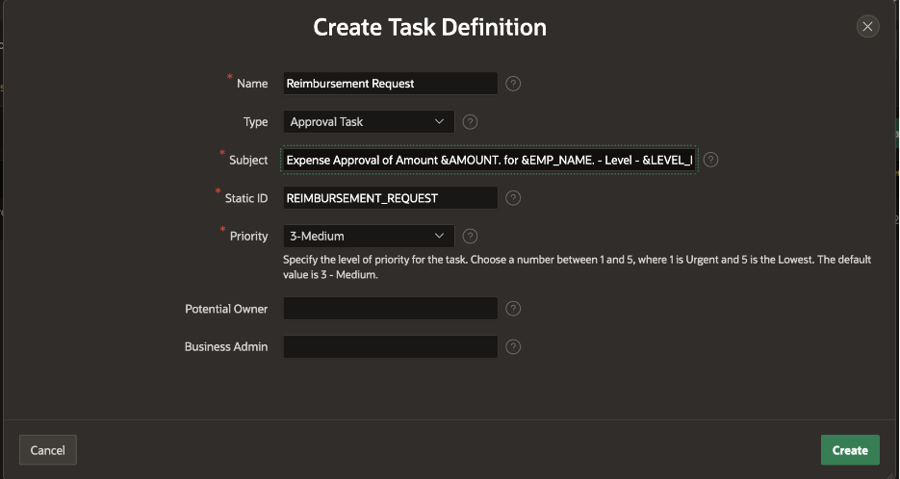

Leave the Potential Owner and Business Administrator fields empty for now.

We can now further configure the Reimbursement Request Task Definition in the **Edit Task Definition** screen that opens once the **Create** is hit.

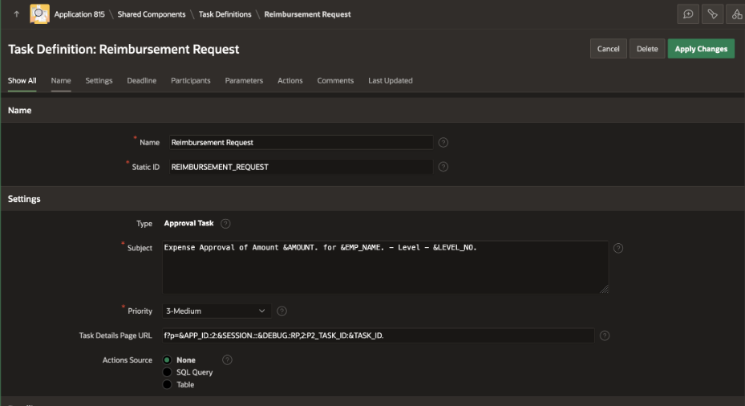

## Generating the Task Details Page

Task Details Page Number is empty. Click on the Create Task Details Page button to generate the details page for this task. You will get a popup dialog asking if the next available page number should be used. Click OK.

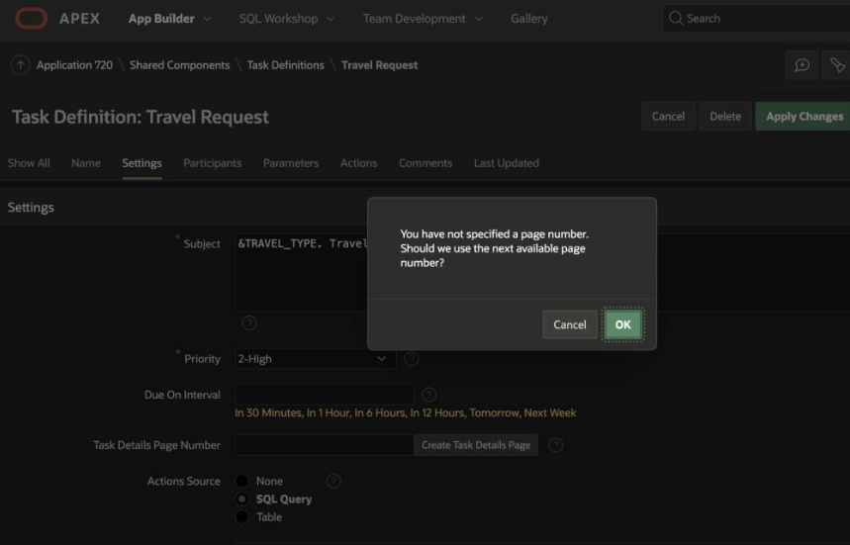

We will find that the Task Details Page Number is replaced by the Task Details Page URL containing the link to the generated Details Page.



**Add Task Participants**

In the Participants section, select Participant Type as Potential Owner and Value Type as SQL Query. In the Value field, add the following SQL query:

**select mgr_name from approval_levels where level_code = :LEVEL_NO**

**Add Task Parameters**

Add the following entries to the Task Parameters section: AMOUNT, LEVEL_NO and EMP_NAME. Here is how the task definition looks now:

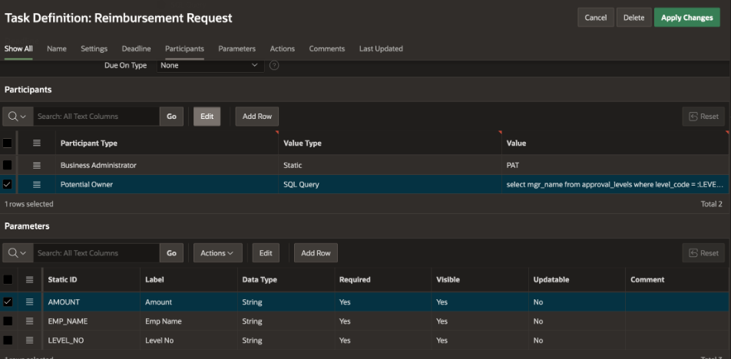

## Creating the Expense Reimbursement Workflow

To design the Expense Reimbursement Workflow:

* Go to the Shared Components > Workflows and Automations > Workflows >Create.
* This brings us to the Workflow Designer (Shared Components >Workflows >Workflow Definition) Page.
* You will find that a new workflow with a new version has been auto-created with a Start Activity, an Execute Code Activity and an End Activity. Remove the Execute Code Activity.
* Modify the Workflow:

**Name** > Expense Reimbursement Workflow

**Title** > Expense Reimbursement for &EMP_NAME.

**Static ID** > EXP_REIMBURSEMENT_WF.

**Workflow Version** > 1.0

## Parameters for the Workflow

We will define the following parameters for the Expense Reimbursement Workflow.

**EMP_NAME (Employee Name)**

**EMP_EMAIL (Employee Email)**

**DESC (Description)**

**AMOUNT (Amount)**

To create a new Parameter, right click on the Workflow in the Tree and select Create **Parameter**. This adds a Parameter with label "New" in the Workflow Tree. Go to the Property Editor and change the Labels and Static IDs to the values given below:

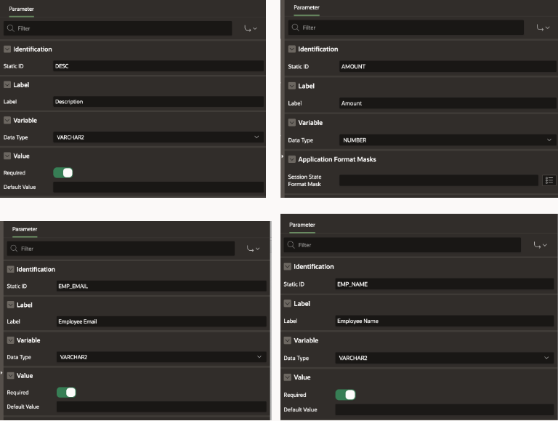

## Variables in the Workflow

Define the following Workflow Variables

MAX_LEVEL initialized to Null, CURRENT_LEVEL initialized to Static Value 1.

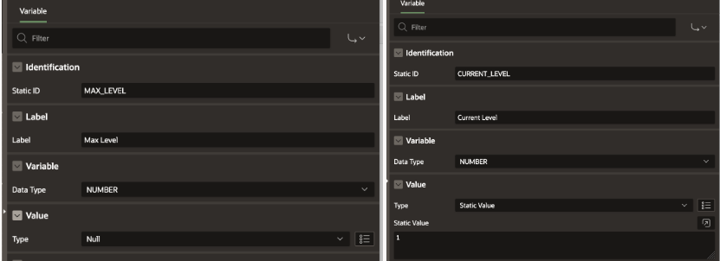

**Activities in the Workflow**

1. **Compute Max Level:** Activity Type : Execute Code

**declare**

**level_no number;**

**begin**

**if :AMOUNT < 500 then**

**level_no := -1;**

**elsif :AMOUNT < 1000 then**

**level_no := 1;**

**elsif :AMOUNT < 5000 then**

**level_no := 2;**

**else**

**level_no := 3;**

**end if;**

**:MAX_LEVEL := level_no;**

**end;**

1. **Approval Needed**: Activity Type: Switch (True False Check)

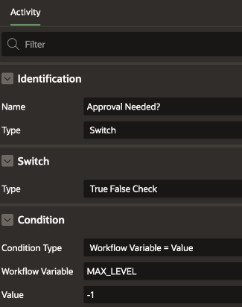

1. **Create Approval Request**: Activity Type: Human Task – Create

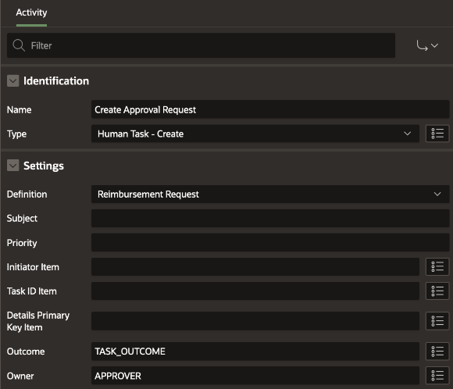

Set the Task Parameters (Amount, Emp Name, Level No) as shown below:

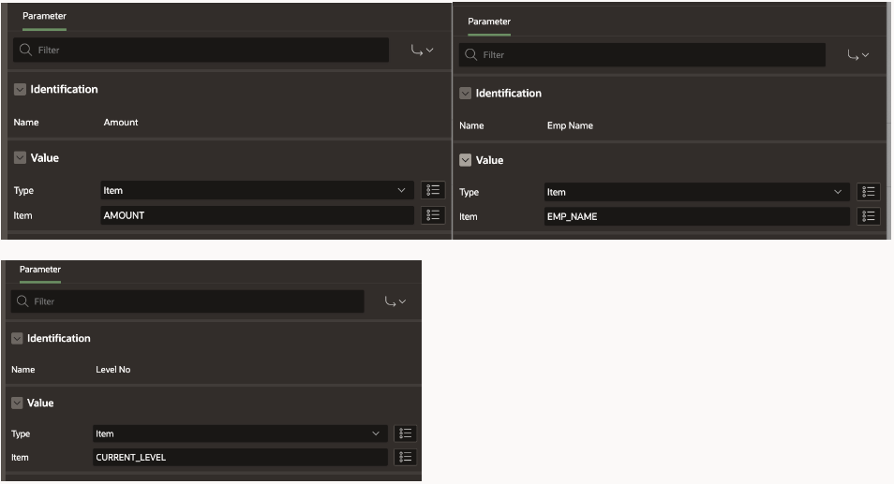

1. **Increment Level**: Activity Type: Execute Code

**begin**

**:CURRENT_LEVEL := :CURRENT_LEVEL+1;**

**end;**

1. **Approved?**: Activity Type: Switch (True False Check)

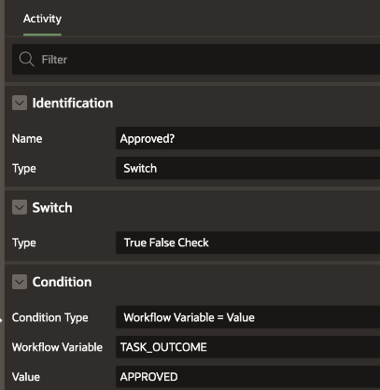

1. **All Approvals Completed?**: Activity Type: Switch ( Compare Workflow Variable)

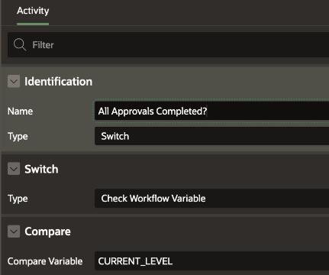

1. **Send Approval Email**: Activity Type: Send E-Mail

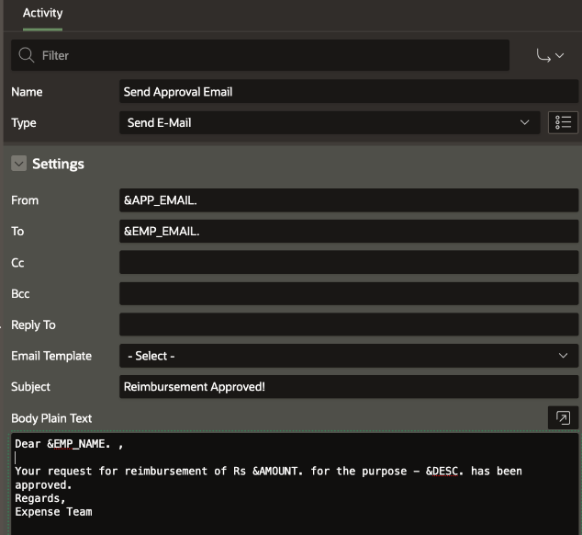

1. **Send Rejection Email**: Activity Type: Send E-Mail

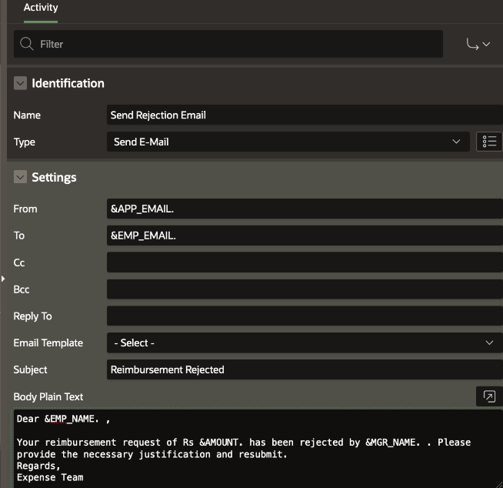

1. **Rejected at First Level?**: Activity Type: Switch (True False Check)

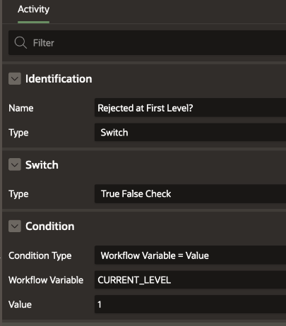

1. **Reset Level**: Activity Type: Execute Code

**begin**

**:CURRENT_LEVEL := 1;**

**end;**

1. **Auto Approved Email:** Activity Type: Send E-Mail

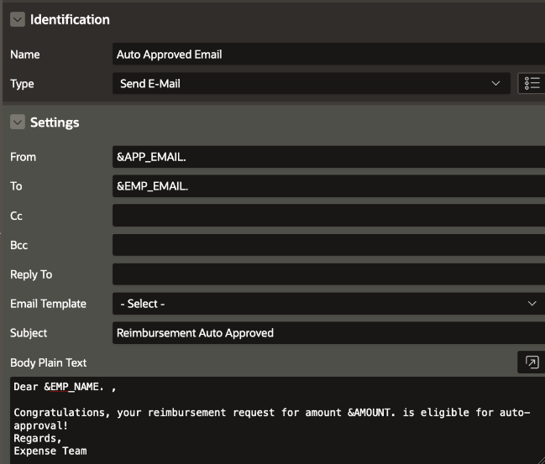

## Adding the conditional connections for the Switch Activities

For the **Approval Needed?**Switch Activity define the **True** and **False** connections as shown below:

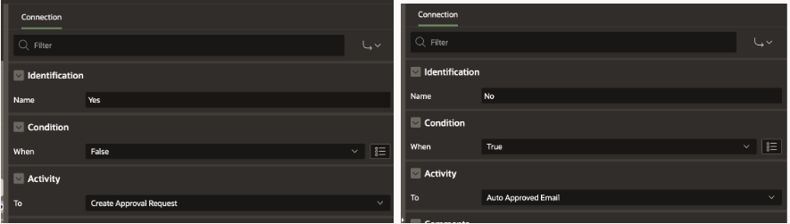

For the Approved? Switch Activity define the True and False connections as shown below:

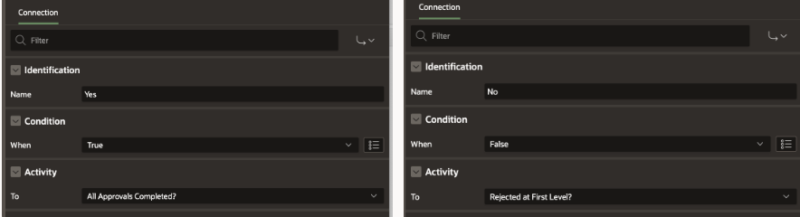

For the Rejected At First Level? Switch Activity define the True and False connections as shown below:

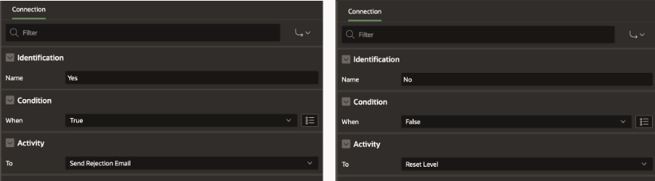

For the All Approvals Completed? Switch Activity; define the conditional connections as shown below:

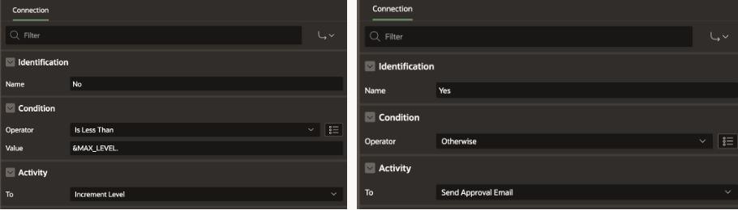

## The Final Workflow Diagram

Link all the activities together so that the final workflow looks like this:

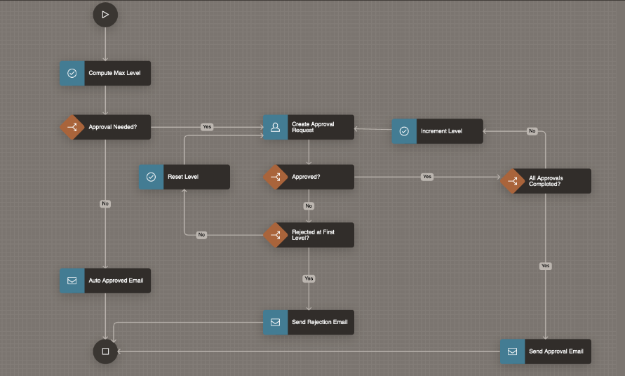

## Creating the Submit Expenses page

Now that we have the task definition and the workflow created, we will create the page which will submit the expense reimbursement request. Submitting this page will create an Expense Reimbursement workflow instance based on the workflow we have just configured.

* Click on **Create Page** in your Expense Reimbursement application. Choose the Page type as Blank Page. Name this page "**Submit Expense**".
* In the Page Designer, add the following Page Items to the Body: Employee Name, Employee Email, Expense Amount and Expense Reason.
* Add a button **SUBMIT** to the Page.
* Navigate to the Processing Tab and create a new Page Process of type Workflow. Name the process "**Submit Expense**".
* Under the Settings, Click the Type and set it as **Start**. Set the Workflow Definition as **Expense Reimbursement Workflow.** Set the Success Message as "Expense Report Submitted!"
* Under Server-Side-Conditions set **When Button Pressed** to SUBMIT

**Set Parameters for the Workflow Page Process**

Under Submit Expense -> Parameters in the Processing section:

* Click on Amount and set it to Page Item P4_AMOUNT
* Click on Description and set it to Page Item P4_EXPENSE_REASON
* Click on Employee Email and set it to Page Item P4_EMP_EMAIL
* Click on Employee Name and set it to Page Item P4_EMP_NAME

Save the changes.

## Creating the Pending Expense Approvals Page

The page will be used by the managers to approve the expense request.

1. Go to the Application Home and click on **Create Page**. In the Create Page Wizard, select **Unified Task List**.
2. In the Create Unified Task List Wizard, enter Name as **Pending Expense Approvals**. Leave the Report Context as **My Tasks**. Click on **Create Page.**
3. This will create the **Pending Expense Approvals Unified task list page** where Managers can log in to **Approve** or **Reject** the expense reimbursement requests.

# Creating the Monitor Expense Workflows Page

We need the page that the submitter of the Expense report will use to monitor the reimbursement workflow.

We use the Workflow Console and Details pages with **Initiated by Me** report context which allows a logged in user to view all Workflows Initiated by him or her.

To create the Workflow Console and Details pages:

1. On the Application home page, select Create Page.
2. Under Components, select **Workflow Console**.
3. Select the Report Context as **Initiated By Me.**
4. For the Form Page, enter **Monitor Expense Workflows**
5. For the Workflow Details page, set the name as **Expense Workflow Details**

## Running the Application

**Setting the APP_EMAIL substitution string**

1. Go to Application Home Page and click on **Edit Application Definition**.
2. Under **Substitutions**, add the following Entry: APP_EMAIL > Email ID of sender
3. Save the changes by clicking on Apply Changes.

**Setting Authentication Method**

1. Go to Shared Components > Authentication Scheme > Oracle APEX Scheme
2. Set Scheme Type > Open Door Credentials

**Run the Application**

Log In as STEVE. Click on Submit Expense to Submit a New Expense Reimbursement Request for ANANYA.

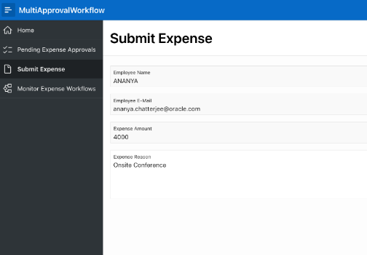

Click on Monitor Expense Workflows and notice that there is an Active Workflow for the Expense Request. Click on the Workflow to view its details.

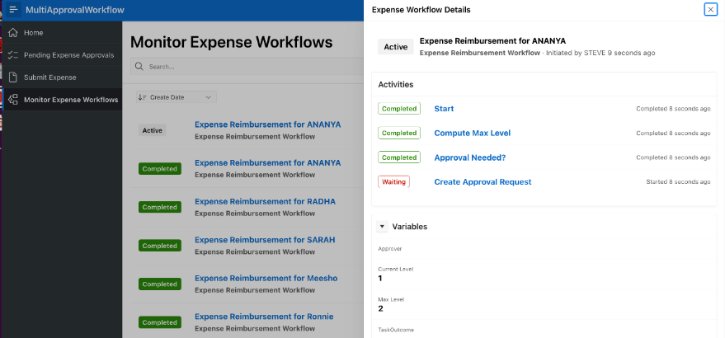

The Details show that the workflow is waiting at the Approval Task.

Log In as **Jane** and go to **Pending Expense Approvals** to Approve the Level 1 of Reimbursement Request.

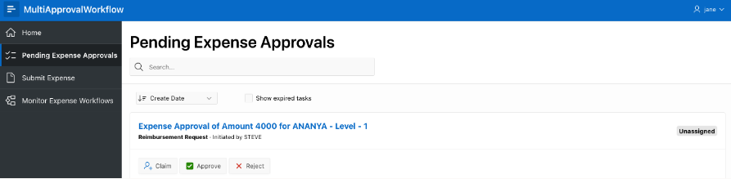

As per our business logic, for Expense Amount between 2000 and 5000 Two Levels of approval are required.

Log out and Log in as **Bo** and go to **Pending Expense Approvals** to Approve the Level 2 of the Reimbursement Request.

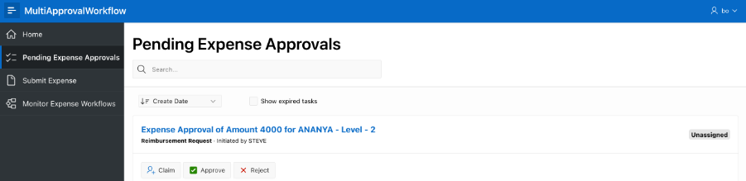

Log out and Log back in as **Steve**.

Navigate to **Monitor Expense Workflows** and verify that the Workflow is in **COMPLETED** state. Click on the workflow to open the details and view all the completed activities.

